Wearable ECG Monitor

University of kent

Masum Ahmed Ma786

2019

1.0.0 Introduction 3

1.1.0 Aim and Objectives 4

2.0.0 Background Research 5

2.1.0 Theoretical Foundation: ECG Waveform 5

2.2.0 Technological State 6

2.3.0 Hardware Design and Implementation 7

2.3.1 Microcontroller 7

2.3.2 ECG Electrodes 7

2.3.3 Source of Noise 7

2.3.4 Acquiring ECG Data 8

2.3.5 EMI – Human Antenna Effect 8

2.3.6 Common Mode Rejection Ratio (CMRR) 8

2.3.7 Data Storage 9

2.3.8 Sampling Frequency 9

2.4.0 Market Research 9

2.4.1 Commercial Products 9

3.0.0 System Design 10

3.1.0 Microcontroller 12

3.2.0 Integrated Biopotential Sensor 12

3.2.1 Lead Bias 14

3.2.2 Interfacing ECG AFE with an MCU 14

3.3.0 Power Supply 15

3.3.1 Battery Charger 16

3.4.0 Software Architecture 18

3.5.0 Android App 19

3.6.0 Bluetooth 5 Communication 19

4.0.0 Development Tools 20

4.1.0 Keil 5 MDK 20

4.2.0 Windisp UART Communication 20

4.3.0 Programming Custom Board 20

5.0.0 Risk Analysis 21

6.0.0 Project Plan and Budget 22

6.1.0 Bill of Material 22

6.2.0 Gantt Chart 22

7.0.0 References 24

# 1.0.0 Introduction

The IoT (internet of things) field in wearable healthcare has received a lot of attention in the last few years due to advancement in computing paradigms; cloud computing, fog computing and edge computing. Machine learning on the cloud has revolutionized traditional healthcare which has led to the surge of new smart health devices. There is a non-invasive glucose monitor which can track glucose levels throughout the day. Omron is developing a smartwatch which can take blood pressure measurement using traditional methodology but at a much smaller scale. Google is using deep learning for detection of eye disease in diabetic patients with outstanding results [1].

Due to increasing world population especially the ageing population, there has been a massive strain on the healthcare system worldwide affecting millions of people. Traditional doctor-patient interaction has lost its effectiveness. The healthcare system as we know is changing from reactive treatment of illness at the hospital to preventive and personalized intervention. Artificial intelligence is getting increasingly sophisticated at emulating humans do so but more efficiently, quicker and cheaper. The potential for AI in the healthcare ecosystem is vast. Smart healthcare devices collect large amounts of processable data which can be examined in real-time and stored on a database to be viewed later. Interactions between doctor and patient are more efficient and patient-orientated since doctors can make better decisions.

The project aims to develop a small battery-powered ECG device that can be worn on the body.

While smart wearable ECG device is not as accurate as a full-scale 12 lead electrocardiograph, it has other significant advantages: it can be worn all day every day. It can collect data throughout the day across a wide range of activities. The more data it collects better preventive model can be established that is personalized to the patient. A large amount of data can also be used to establish patterns using machine learning and predict potential health problems before they arise.

## 1.1.0 Aim and Objectives

* Design a low power wireless ECG acquisition which can operate continuously for a day without recharging.
* Design an Algorithm to evaluate ECG and extract breathing rate, heart rate and heart rate variability.
* Use standard communication protocols such as BLT5 / Thread to connect to a gateway device (smartphone, raspberry pi etc.)
* Design an android based app to display the data in real-time.
* Setup cloud service for medical professionals to access the data remotely.

Deliverables:

* A low power microcontroller system with a biopotential sensor for ECG measurement. (Hardware)
* Custom buck-boost power circuitry with high efficiency and low idle current consumption.
* Voltage reference circuit to provide clean power reference for analogue measurements.
* Embedded firmware that can detect heart rate from ECG data & wireless communication using the Bluetooth 5.1 protocol on-chip.
* Implement features such as deep sleep, variable transmission power to save battery.
* An android app using java environment to display data in real-time.
* Web app using JavaScript to display historical data for health profession analysis.

# 2.0.0 Background Research

## 2.1.0 Theoretical Foundation: ECG Waveform

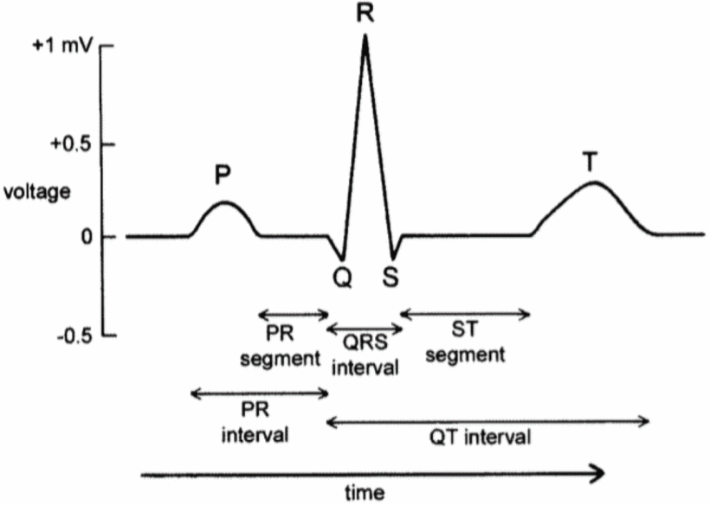

Figure 1 ECG waveform for one cardiac cycle

ECG measures the bio-potential generated by different contraction of the ventricles. The electrical impulse is generated in the sinoatrial node located in the atria [9]. The p wave as shown in figure 1 indicates atrial depolarization (atrial systole). There is a slight delay from the end of the P wave and the start of the QRS complex. This is caused by a cluster of cells called the atrioventricular node. This delay allows the atria to contract before the ventricle contracts. The QRS complex indicates ventricular contraction and depolarization (ventricular systole), this is caused by the electrical impulse moving from the AV node (atrioventricular node) through the bundle of His where it splits into the right-left bundle and then to the Purkinje fibres as shown in figure 2.

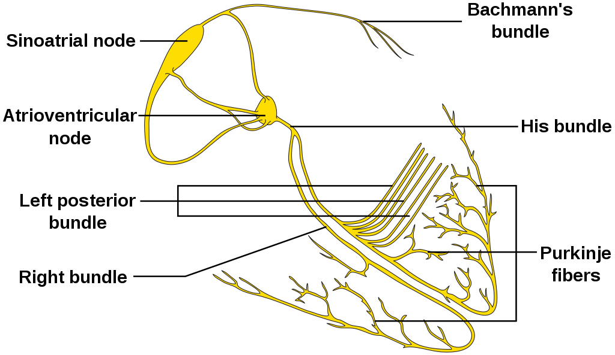

Figure 2 Electrical path of the heart during the cardiac cycle

In this project, I am only interested in the QRS complex, specifically the peak R amplitude from which the heart rate and heart rate variability will be calculated.

## 2.2.0 Technological State

Wireless technology and smart biosensors AFE (analogue front end) are the backbones of the smart healthcare system. There is a wide range of different wireless technology today supported by consumer devices: Wi-Fi, Bluetooth / BL Mesh, Thread, ANT, RFID, Zigbee, GSM/3G/4G. There are pros and cons to using all of these and specific technology is suited to certain project and environment.

There are two commonly used techniques in the industry to measure the heart rate, PPG (Photoplethysmography) and EEC (electrocardiography). PPG uses low-intensity infrared light to sense the change in blood flow during the cardiac cycle. The voltage signal from the receiver is inversely proportional to the volume of blood flowing. PPG is less accurate, more susceptible to motion artefact and consumes more power. The waveform of the PPG sensor contains fewer data related to the cardiac cycle [11][12].

## 2.3.0 Hardware Design and Implementation

There are multiple different approaches to designing analogue and digital hardware for ECG acquisition. One of the most advanced methods has been presented by Dr Shihui Yin et al from the University of Arizona who designed and fabricated the analogue hardware on 65nm CMOS logic [13]. It is extremely low power only 1.06µW during operation. Unfortunately, this is outside the scope of this project due to budget, time, tools limitation. It will be much easier to work with consumer IC’s and design custom PCB to integrate all the AFE’s and processing hardware. This approach was taken by theses research projects [8][14][15].

### 2.3.1 Microcontroller

ATmega328P (Arduino) 8bit microcontroller was used to acquire the ECG voltage data in [14][8] and MSP430 in [15]. The microcontrollers were chosen by the researchers because it has a lot of third-party libraries and interfacing them with a third-party device is well documented. However, the microcontrollers are slow only 16MHz, uses old 8 & 16-bit architecture, consumes a lot of power, the ADC resolution is limited to 8bits (atmega328P) and 10 bits on the MSP430 and most importantly Bluetooth is not integrated.

### 2.3.2 ECG Electrodes

Ag/AgC1 electrodes are widely used in ECG measurement due to their low skin to electrode contact impedance however, they are not suitable for continuous long-term measurement as it can irritate the skin and cause skin allergies [17]. An alternative dry electrode made from metal, conductive rubber or conductive fabric was found to be suitable for long term use [18][19].

### 2.3.3 Source of Noise

List of significant sources of noise in ECG data [22]

* Mains power lines produce 50Hz periodic interference.
* Movement can cause loss of contact between the skin and the electrode; this can result in a fast change in the potential difference in the signal which will result in false-positive readings.
* Muscle movement can cause noise from the electrical activity of the muscle.
* Respiration and general movement can cause baseline wander.

Signal to noise ratio can be improved by eliminating the above sources of noise. This can be done by implementing high and low pass filter and some software filtering.[8]

### 2.3.4 Acquiring ECG Data

“ECG input signal on the skin is very low in amplitude (<1 mV) and noisy. ECG voltage signal must be amplified, then high pass filtered to get rid of DC skin potential and battery effects. Then it must be low pass filtered to cut off high-frequency noise and mains interference” [16]. There seem to be many ways to achieve this. Traditionally electrodes would be connected to a series of operational amplifiers configured to perform the above function (amplify, high pass, low pass). However, this method is bulky because it requires a lot of components and consumes a significant amount of power.

The custom-designed integrated circuits prosed, in the study [14]. The researcher used the AD8232 IC which is a single chip with integrated OpAmps. The resistors connect to the pins of the AD8232 pins which can be altered to configure and set limits for the filters. Using the above configuration reduces PCB space however the design is still limited by the resolution of the ADC on the microcontroller.

### 2.3.5 EMI – Human Antenna Effect

The user body can act as an antenna which can pick up electromagnetic signals mostly in the range of 50 – 60 Hz common mode noise from mains electrical AC power lines. A large amount of electromagnetic interference is coupled to the user’s body through the skin [20]. The source of noise must be eliminated in hardware. The solution provided by the researcher uses the right leg as common noise input which can be rejected from the original differential ECG signal, more on this on selection 2.2.6 and why it is not viable according to [21].

### 2.3.6 Common Mode Rejection Ratio (CMRR)

Having a ground electrode to reduce noise is not suitable in a wearable device because it will introduce high leakage current during operation [21]. A system with high CMRR can be achieved by implementing an extra stage in the hardware signal processing. As mentioned in 2.2.5 the body is good at picking up common mode signals; noise that affects both electrodes equally. Achieving a system with a high common-mode ratio is important [22].

### 2.3.7 Data Storage

Continuous measurement of ECG will result in a lot of data. To avoid loss of data when the device is not connected to a suitable Bluetooth device or if the signal connection is lost data must be stored in a suitable place.

MicroSD card integration is simple and used by many research projects [8][15]. If the raw ECG data is not kept rather the induced HR, then it will be suitable to use the onboard flash in the microcontroller itself. Micro SD card may not be suitable in a low power wearable device. It can consume around 100mA at 3.3V. An alternative option would be to use NOR flash chips.

### 2.3.8 Sampling Frequency

It was determined sampling frequency low as 50Hz can be used to obtain HRV by software interpolation [23]. The researcher tested a range of sampling frequency from 5KHz to 50Hz and run statistical tests on each of the acquired data. The researcher also noted the R peaks were slightly distorted due to low sampling frequency. The optimal range of sampling rate for spectral analysis of HRV parameters is between 250 and 500 Hz [24].

## 2.4.0 Market Research

### 2.4.1 Commercial Products

**Amazfit Health Band 1S** Is a PPA based smart band with an ECG sensor. It uses PPA technology to continuously monitor the heart rate if it detects arrhythmia then it alerts the user and asks them to take an ECG reading by placing a finger on top of the band. The data is sent to the cloud which is then processed by AI. The data can be accessed by the user (free for the first 6 months). The device is manufactured and developed by a Chinese company and is not widely adopted in the west.

**Welch Allyn TAGecg sensor** Is an ECG based chest sensor which continuously records the ECG of the user. It examines the heart rate and has built an algorithm in the local system to detect arrhythmia. The data is also synced to the cloud where it can be further examined by the medical profession. The device is manufactured and developed by Welch Allyn an American company who develops a medical device for private healthcare in America.

# 3.0.0 System Design

The system will have bipotential ECG AFE sensor which will take differential measurement from 3 wire electrode (ECG P, ECG N). It will be powered from the +3.3V and +1.8V rail. The ECG sensor will be interfaced to the microcontroller via SPI (Serial Peripheral Interface).

To reduce PCB space and power consumption a microcontroller with wireless capability will be utilised. It will be interfaced with NOR flash to store data while the system is not connected to an external Bluetooth master node. It will be time synced relative to the connected master node since it does not have a real-time clock. Alongside the ECG data, relative timing information will be stored. This information is important to calculate the heart rate & heart rate variability of the user.

The embedded hardware will connect to a smartphone via Bluetooth and send its stored data. This data will be temporarily stored on the phone then uploaded to a server connected to the internet. There will be a companion app on a smartphone which will display current data send by the embedded hardware and historic data stored on an online database. For third party public access there will be a web portal where historic data can be viewed.

The system will have the ability to show live ECG and temperature data in real-time through the android application. At this stage, the mobile phone will not be doing any preprocessing just acting as a monitor for the data.

The cloud system will be set up on a separate computer connected to the internet. It will use MySQL database to store the data which can be accessed on via time and key events. The system will only focus on the single-user system to reduce design complexity.

Website hosted on a server will be utilized to develop a web portal to access data from the database for public usage. The system will be protected from unauthorised access by user login.

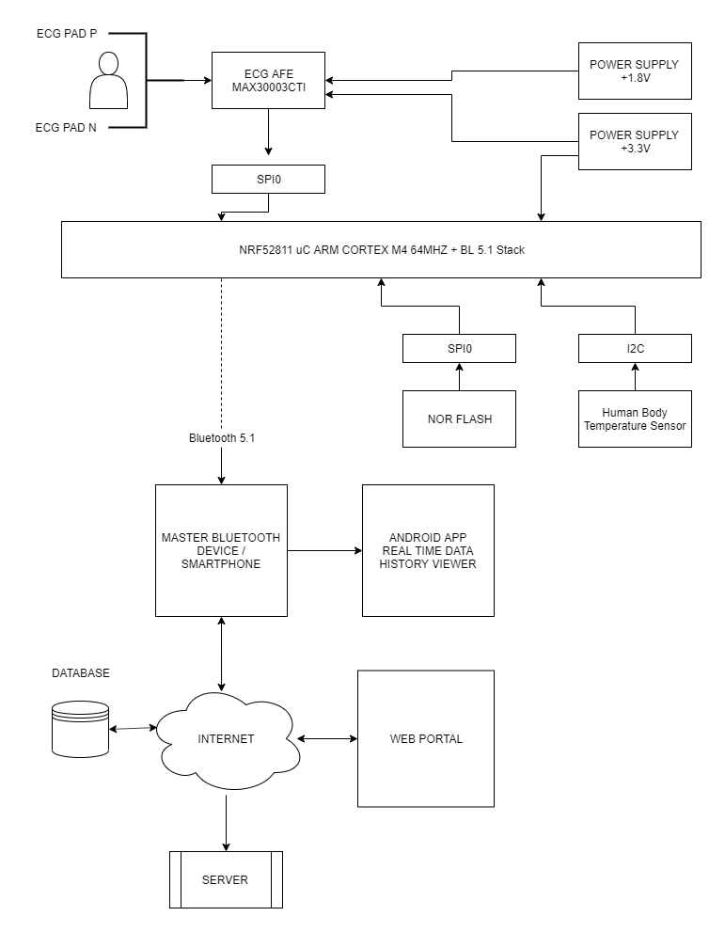

Figure 3 High-level system architecture diagram

## 3.1.0 Microcontroller

**Espressif ESP32 WIFI & BLE** is an alternative option since I have used this soc before, however, this would not fit the project since the power consumption during transmission is too high 100mA vs ~4.6mA (nRF52811). The footprint of the IC is too small to solder by hand and the processor is over specced for what I need it for. 240mhz @ dual-core is too much power. It also implements an older protocol: Bluetooth 4.2.

**Nordic Semiconductor nRF52811** is a low power 64mhz arm cortex M4 based microcontroller with Bluetooth 5.1 protocol, including Long Range and Direction Finding, 802.15.4, Thread and Zigbee in a 6mm2 48pin QFN package. The microcontroller has low power consumption during idle and only 4.6mA during transmission at 0dB this makes it ideal for wearable devices.

When designing with this microcontroller the SPI1 instance cannot be used while using I2C peripheral because they both share the base memory address.

I have chosen this microcontroller over Arduino(atmega328P) and mbed (lpc1768) because it has the Bluetooth stack integrated into the microcontroller. The datasheet is comprehensive and there is a lot of online support. In industry, semiconductor devices are widely used where esp32 and Arduino are limited to maker and research projects due to licencing incompatibility.

## 3.2.0 Integrated Biopotential Sensor

**BMD101** Is a popular IC used in commercial ECG band due to its size and performance, however, availability is non-existent in the EU/UK/US market. The datasheet is only 14 pages and covers the basic aspects of the IC.

**MAX30003CTI+** Ultra-Low Power, Single-Channel Integrated Biopotential dual electrode. It’s a complete analogue front-end solution for wearable applications. It packs all the operational amplifiers internally in a small QFN package. This is an improvement upon Dr B. Babusiak analogue design [8] because it saves PCB space, power-efficient and has higher CMRR.

The IC has built-in R-R detection which uses the Pan-Tompkins algorithm [2] to determine the heart rate. However raw data can be sent to the microcontroller by changing the registers. It simplifies filtering by internally incorporating a low and high pass filter reducing the external components. The device can also be configured to output raw 15.5bit ADC reading (sample and hold) without any modification.

Baseline wander is an issue with ECG (low-frequency noise) which can be expensive (compute time) in software to fix. The AFE tries to take care of this at a hardware level. The gathered data has a high signal to noise ratio (SNR). There are three recommended options for the cut off frequency: 4.4Hz, 0.4Hz, and 0.04Hz. Setting the cut off frequency to 4.4Hz provides the most motion artefact rejection, the trade-off is waveform quality.

The device’s ECG channel contains an input amplifier that provides low-noise, fixed-gain amplification of the differential signal (ECG Positive, ECG Negative), rejects differential DC voltage due to electrode polarization, rejects common-mode interference primarily due to AC mains interference, and provides high input impedance to guarantee high CMRR (Common Mode Rejection Ratio).

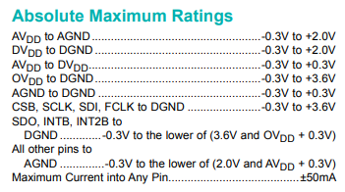

Figure 4 Pin input voltage rating from max30003 datasheet

The datasheet (figure 4) shows AVDD -> AGND must be <+2.0V and DVDD -> DGND <+2.0V this means I need dual voltage rails 3.3V and 1.8V since the AFE is not high power I will use low IQ (quiescent current) low dropout linear regulator (LDO). There are 2 different grounds, AGND & DGND. The ground will be connected to each other by a 0 ohms resistor.

##### 3.2.1 Lead Bias

The ECG AFE limits the input of ECGP and ECGN DC input common-mode range to VMID ±150mV. This means if there’s a significant bias voltage it can result in the signal getting clipped at VMAX and VMIN resulting in data loss. This can be fixed using external lead biasing resistor, fortunately, this IC has internal selectable lead biasing resistor: 50MΩ, 100MΩ and 200MΩ CNFG_GEN (0x10) register can be used to select a configuration.

##### 3.2.2 Interfacing ECG AFE with an MCU

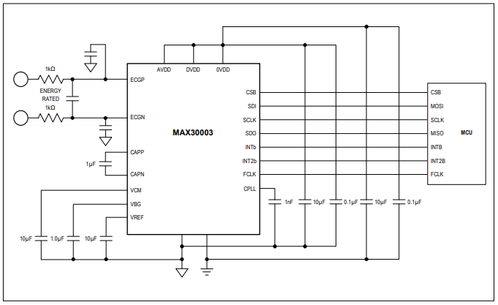

Figure 5 ECG AFE interfacing with a generic micro-controller

Integration to nrf52811 microcontroller GPIO pin can be configured as required in software, therefore, it does not matter which pin the corresponding pins connect to. MOSI, SCLK, MISO are SPI specific pins while INTb and INTa are interrupted pins to indicate when data is ready. FCLK is the clock to max30003 this will be a GPIO pin controlled under interrupt to change the clock edge. CSB is chip select to reliable / disable SPI communication there can be multiple devices on the SPI interface.

|  |  |
| --- | --- |
| Name | Function |
| **CBS** | Active low chip select input. enables the serial interface |
| **SDI** | Serial Data Input. SDI is sampled into the device on the rising edge of SCLK when CSB is low |
| **SCLK** | Serial Clock Input. Clocks data in and out of the serial interface when CSB is low |
| **SDO** | Serial Data Output. SDO will change state on the falling edge of SCLK when CSB is low. SDO is high z when CSB is high. |
| **INTb** | Interrupt Output. INTB is an active low-status output. It can be used to interrupt an external device. |
| **INT2b** | Interrupt 2 Output. INT2B is an active-low status output. It can be used to interrupt an external device. |
| **FCLK** | External 32.768kHz Clock that Controls the Sampling of the Internal Sigma-Delta Converters and Decimator. |

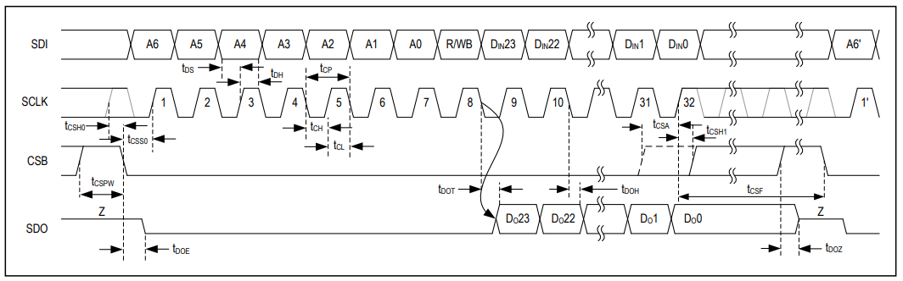The timing characteristics (figure 6) is used to write the SPI driver software. It outlines timing limits and pins logic during operation, it also outlines when the data is ready to be read and when to write. The full table can be accessed on page 7 of the datasheet.

Figure 6 Timing characteristics max30003 datasheet p7

## 3.3.0 Power Supply

For the project, it makes sense to use a rechargeable battery. Lithium-ion polymer battery (LIPO) comes in small packages with a large capacity. Making it suitable for wearable / portable device since it can store a lot of power in a small size. The short circuit current for LIPO battery is a lot higher than alkaline batteries, therefore, can cause fires easily if not monitored strictly [7]. The proposed design to monitor the battery voltage while charging. This is a backup protocol in case the charging IC is misbehaving see figure 7 for power supply design diagram.

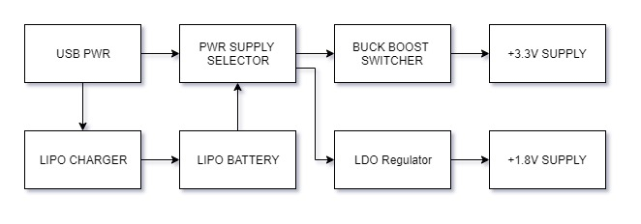

Figure 7 Power supply system design

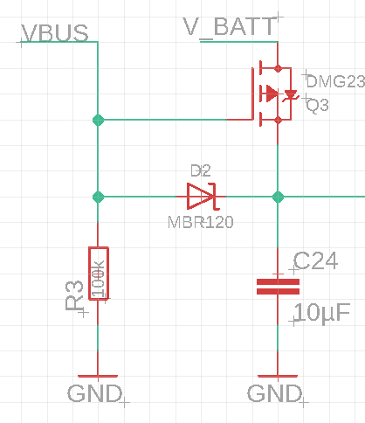The normal battery level is 3.7V and it can range from 4.2V to 2.2V. Since the system voltage level ist at 3.3V, the power supply must be in buck configuration above 3.3V and in boost configuration below 3.3V. When the USB charging cable is connected, the system will be powered from USB power rather than battery power. This resolves the issues of charging the battery while providing power. This is implemented using N channel MOSFET (Q3) and a diode. When the USB cable is connected Q3 is disabled since gate voltage is at VBUS, this cuts off the V_BATT power in. When the USB cable is disconnected the gate voltage is GND (pulled down by R3 resistor) which enables Q3. D2 diode stops the current flowing in the opposite direction note figure 8 for further details.

Figure 8 Digital logic to select USB power over LIPO power if it is present.

### 3.3.1 Battery Charger

To charge the LIPO battery MCP73831 IC will be used from microchip because it requires minimal external components and it is in a footprint that can be soldered by hand without too much effort. This is different from the one used in [8], MCP7337 was not chosen because it consumes a lot more PCB space. mcp73837 has a feature that is not available on the mcp73837 due to limited pins. To get the same level of capability as the bigger brother I will not be following the recommended application implementation design since I want to control the charger IC using the microcontroller. Unfortunately, this IC does not have an enable disable pin to control the IC unlike mcp73837 and the status pin is configured to connect to an LED. I want the microcontroller to know when the battery is charged and when it is charging. Figure 9A shows a typical application design and figure 9B shows the modified design.

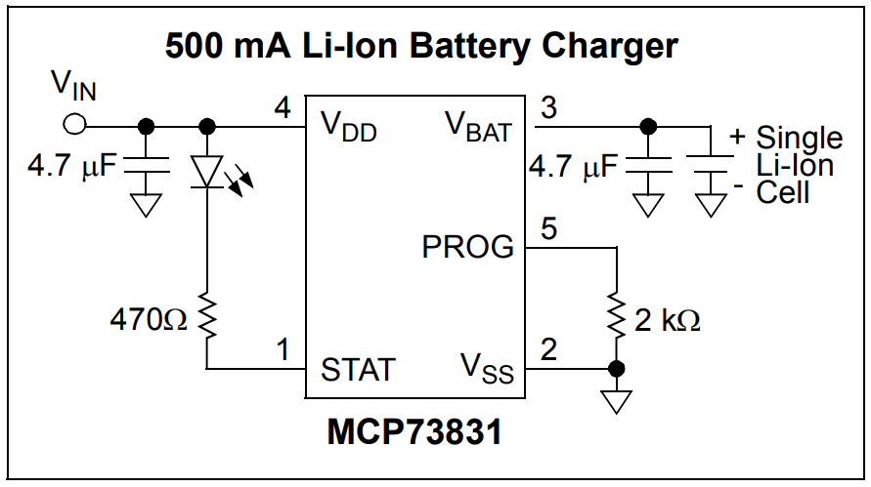

Figure 9A Typical design implementation of MCP73831

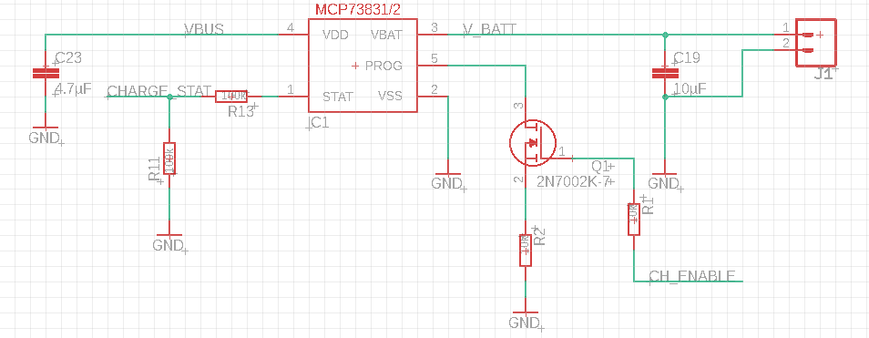

Figure 9B Custom design implementation proposal

I have used a P channel MOSFET with the gate connected to a GPIO pin on the microcontroller. The source to base resistance is around 1 ohm so it should have minimal effect on the charging current which determined by the formula $(1)$ (1 ) $Ireg= \frac{1000v}{Rprog}$*A charge current programming resistor must be connected from PROG to VSS. If the PROG pin is open or floating, the MCP73831/2 is disabled and the battery reverse discharge current is less than 2 µA* extract from mcp73831 datasheet. I am not using reverse battery protection diode because it will consume power while idle and the voltage drop is significant.

Where Ireg = in milliohms, Rprog = in kilo-ohms.

Charge status pin is tri-state and requires a pull-down or a pull-up. During the logic high, the status pin VDD is same as STAT which can be as high as 5V, therefore, I have used a resistor divider.

## 3.4.0 Software Architecture

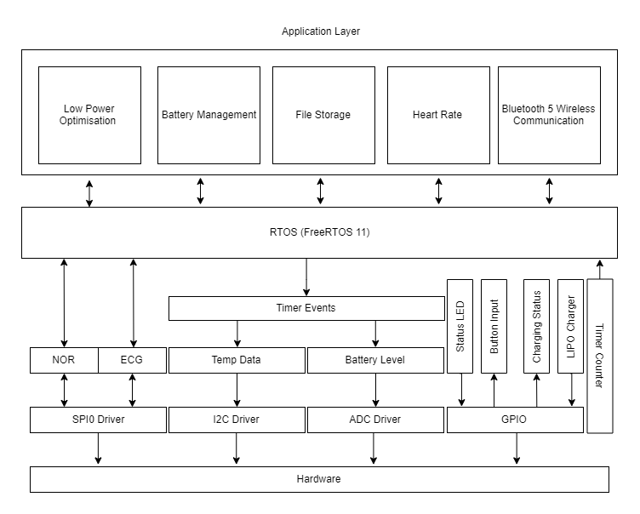

Figure 10: Software design layers

The embedded software will consist of subprograms which will be responsible for different tasks. Figure 10 outlines the smaller components of the software breaking it down into layers bottom being closer to the hardware. The higher layers are general-purpose code, they are generally less restricted by the hardware making it more portable.

FreeRTOS will be used as the real-time operating system because it is free and open-source. On top of the RTOS will be my custom application code among the Bluetooth stack from a Nordic semi (manufacture). Below the RTOS will be the hardware determined code, responsible for controlling the peripherals on the microcontroller.

## 3.5.0 Android App

Andriod studio IDE and java programming language will be used to create the android application. The resources such as images and gfx design will be obtained from openGFX package. It will be my first time developing an android application; therefore, extra time was given on the grant chart to learn java and JavaScript. Java was chosen over Kotlin because it has more resources and my course teaches java. JavaScript will be used to design buttons, logos, animation etc. I hope to interface the app with Bluetooth hardware on the android phone and connect to the embedded hardware.

## 3.6.0 Bluetooth 5 Communication

Bluetooth is a standardised protocol for transmitting and receiving data wirelessly on the 2.4GHz channel. Its secure, short-range, low power and cost and requires minimal external hardware. Bluetooth has standardised test of rules and specification which differentiates it from other standards: WIFI, ZigBee, ANT and Thread.

The BL is standard is published and maintained by the bluetooth.com organisation. The specification outlines all aspects of Bluetooth however its 2985 pages long.

Bluetooth network utilises master/slave model to control when the device can transmit data. Every Bluetooth device has a unique 48-bit MAC address (BD_ADDR) presented in 12-digit hexadecimal format. Most significant half of the address identifies the manufacturer and the lower 24bit is the uniqueness. MAC address is used in software to identify hardware and keep track of communication between that hardware and itself. The microcontroller I will be using has Bluetooth integrated. I will be using the Bluetooth stack provided by the manufacturer (Nordic Semiconductor).

# 4.0.0 Development Tools

## 4.1.0 Keil 5 MDK

Keil will be used as programming and flashing platform because it provides good compatibility with the chosen microcontroller and I have used this IDE during my year in industry. I will be using the NRF SDK on this platform. Among their own software library integrated into the IDE itself. Keil allows programming using debuggers such as Segger JLINK however the cost of a debugger is several times the budget of this project.

## 4.2.0 Windisp UART Communication

Windisp is a serial communication terminal, I will be using this tool extensively during development. It will communicate with the embedded system using UART and display data in a readable format. Unfortunately, it’s not able to do graphs directly but it is able to create.CVS files; using excel I will be able to create trend files and graphs.

## 4.3.0 Programming Custom Board

The microcontroller cannot be programmed via UART (RS232). Which is a major limitation because it means I must use SWDIO pin to program the device. This requires external tools which are very expensive. The NRF52DK has a secondary processor used just for programming and interfacing it to MBED. I will be utilising the dev kits secondary processor to flash my microcontroller.

# 5.0.0 Risk Analysis

|  |  |
| --- | --- |
| **Risk** | **Precaution Taken to Minimise Risk** |
| Out of stock parts | All the parts used in the project can be sourced from multiple different companies as well as the manufacturer. |
| Incompatible software | I have downloaded and installed all the software already to make sure its compatible with my system |
| Delay in a custom board | I will be using development boards while the custom board manufactured and assembled. |
| Damaged PCB | I have given myself time to manufacture 2 versions of the PCB. |
| Design / Logic Fault | Before starting the layout, the schematic will be checked to make sure everything is connected correctly. |
| Running out of time | I am planning to implement an incremental development process. Core things like hardware and ECG data will be a priority then will come the extra features. |
| Hard stuck coding | I will use a tool called windisp to debug the code to find where the problem is. Also, debuggers tools such as Segger JLink integrated on the dev board can be used to resolve coding issues. |
| Damaging boards while soldering | I will order multiple copies of the same version of the PCB if one gets damaged it will not affect the progression of the project. |

# 6.0.0 Project Plan and Budget

## 6.1.0 Bill of Material

|  |  |  |  |  |
| --- | --- | --- | --- | --- |
| **Quantity** | **Parts ID** | **Price (1 unit)** | **Supplier** | **Stock Code** |
| 2 | NRF52811 | £3.19 | Mouser | 949-NRF52811-CAAA-R |
| 2 | MAX30003 | £7.33 | Mouser | 700-MAX30003CTI+ |
| 1 | AT25QF128A-SHB-T | £1.25 | Mouser | 988-AT25QF128A-SHB-T |
| 1 | MAX30205 | £1.92 | Mouser | 700-MAX30205MTA+ |
|  | SMD Resistors | £8.00 |  |  |
|  | SMD Cap | £8.00 |  |  |
|  | SMD Inductor | £5.00 |  |  |
| 2 | MCP73831 | £0.47 | Mouser | 579-MCP73831T-2ACIOT |
| 1 | Turnigy 200mAh | £1.89 | Hobby King | 9067000498-0 |
| 2 | LDO | £0.25 | Mouser | 579-MCP1811AT-042/TT |
| 1 | Max30003 DK | £19 | Mouser | 700-MAX30003WING |
| 5 | PCB | £4 |  |  |
| 1 | JLINK Programmer | - | - |  |
| 1 | Nrf5240 UBB Dev Board | £8.52 | Mouser | 949-NRF52840-DONGLE |
|  | Total | £94.81 | - |  |

## 6.2.0 Gantt Chart

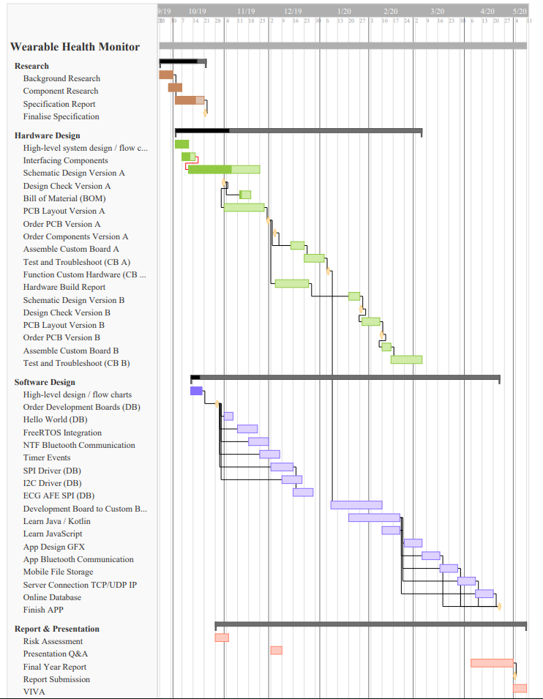

# 7.0.0 References

[1]

Gulshan V, Peng L, Coram M, et al. Development and Validation of a Deep Learning Algorithm for Detection of Diabetic Retinopathy in Retinal Fundus Photographs. JAMA. 2016;316(22):2402–2410. doi:10.1001/jama.2016.17216

[2]

Pan, J. and Tompkins, W. (1985). A Real-Time QRS Detection Algorithm. *IEEE Transactions on Biomedical Engineering*, BME-32(3), pp.230-236.

[3]

P., Chiang, P., Tarng, D. and Yang, C. (2018). Mathematical derivation, circuits design and clinical experiments of measuring blood flow volume (BFV) at arteriovenous fistula (AVF) of hemodialysis (HD) patients using a newly developed photoplethysmography (PPG) sensor. *2018 19th International Symposium on Quality Electronic Design (ISQED)*.

[4]

Arun, U., Natarajan, S. and Rajanna, R. (2018). A Novel IoT Cloud-based Real-Time Cardiac Monitoring Approach using NI myRIO-1900 for Telemedicine Applications. *2018 3rd International Conference on Circuits, Control, Communication and Computing (I4C)*.

[5]

Rahman, A., Rahman, T., Ghani, N., Hossain, S. and Uddin, J. (2019). IoT Based Patient Monitoring System Using ECG Sensor. *2019 International Conference on Robotics, Electrical and Signal Processing Techniques (ICREST)*.

[6]

Nurdin, M., Hadiyoso, S. and Rizal, A. (2016). A low-cost Internet of Things (IoT) system for multi-patient ECG's monitoring. *2016 International Conference on Control, Electronics, Renewable Energy and Communications (ICCEREC)*.

[7]

Vitols, K. (2015). Lithium ion battery parameter evaluation for battery management system. *2015 56th International Scientific Conference on Power and Electrical Engineering of Riga Technical University (RTUCON)*.

[8]

Babusiak, B., Gala, M. and Borik, S. (2014). Hardware design of ECG data logger. *2014 ELEKTRO*.

[9]

Anthony Dupre MS, MS Sarah Vincent, Paul A. Iaizzo, "Basic ECG Theory Recordings and Interpretation", Chapter Handbook of Cardiac Anatomy Physiology and Devices,

[10]

Chavdar Levkov, Georgy Mihov et al, "Removal of power-line interference from the ECG: a review of the subtraction procedure", Biomedical Engineering Online, 2005.

[11]

Lu, G., Yang, F., Taylor, J. and Stein, J. (2009). A comparison of photoplethysmography and ECG recording to analyse heart rate variability in healthy subjects. *Journal of Medical Engineering & Technology*, 33(8), pp.634-641.

[12]

Lu, G. and Yang, F. (2009). Limitations of Oximetry to Measure Heart Rate Variability Measures. *Cardiovascular Engineering*, 9(3), pp.119-125.

[13]

Yin, S., Kim, M., Kadetotad, D., Liu, Y., Bae, C., Kim, S., Cao, Y. and Seo, J. (2017). A 1.06 μw smart ecg processor in 65 nm cmos for real-time biometric authentication and personal cardiac monitoring. *2017 Symposium on VLSI Circuits*.

[14]

Tanweer, M. and Halonen, K. (2019). Development of wearable hardware platform to measure the ECG and EMG with IMU to detect motion artifacts. *2019 IEEE 22nd International Symposium on Design and Diagnostics of Electronic Circuits & Systems (DDECS)*.

[15]

Chen, W., Chen, Y., Chou, C. and Fang, W. (2015). An EEG analog front-end design with wireless communication module for a portable EEG monitoring system. *2015 IEEE 5th International Conference on Consumer Electronics - Berlin (ICCE-Berlin)*.

[16]

Lacirignola, F. and Pasero, E. (2017). Hardware design of a wearable ECG-sensor: Strategies implementation for improving CMRR and reducing noise. *2017 European Conference on Circuit Theory and Design (ECCTD)*.

[17]

Ju-Yeoul Baeka, Jin-Hee An, Jong-Min Choi, Kwang-Suk Park, Sang-Hoon Lee. "Flexible polymeric dry electrodes for the long-term monitoring of ECG," Sensors and Actuators A: Physical, vol. 143, 2008, pp. 423-429.

[18]

S. H. N. Chang, Y. Ryu, K. Seunghwan, "Conductive rubber electrode for wearable health monitoring," in Proceesing of the 2005 IEEE Engineering in Medicine and Biology 27th Annual Conference, Shanghai, China, 2005. pp. 3479-3481.

[19]

Carey R. Merritt, H. Troy Nagle, and Edward Grant, "Fabric-based active electrode design and fabrication for health monitoring clothing," IEEE Transactions on information technology in biomedicine. vol. 13, 2009, pp.274-280.

[20]

Acharya, V., 2011. Improving common-mode rejection using the right-leg drive amplifier. *Texas Instruments*, pp.1-11.

[21]

Lacirignola, F. and Pasero, E. (2017). Hardware design of a wearable ECG-sensor: Strategies implementation for improving CMRR and reducing noise. *2017 European Conference on Circuit Theory and Design (ECCTD)*.

[22]

A. S. Barhatte, R. Ghongade, and S. V. Tekale, “Noise analysis of ECG signal using fast ICA,” *2016 Conference on Advances in Signal Processing (CASP)*, 2016.

[23]

S. Mahdiani, V. Jeyhani, M. Peltokangas, and A. Vehkaoja, “Is 50 Hz high enough ECG sampling frequency for accurate HRV analysis?” *2015 37th Annual International Conference of the IEEE Engineering in Medicine and Biology Society (EMBC)*, 2015.

[24]

G. D. Pinna, R Maestri, A. Di, R. Colombo, G. Minuco, "The accuracy of power spectrum analysis of heart rate variability from annotated RR lists generated by Holter systems", Physiological Measurement, vol. 15, no. 2, pp. 163-179, May 1994.

|  |  |  |
| --- | --- | --- |
| **Section I: Project details** | | |
| Project title: | Wearable ECG Monitor | |
| Planned start date: 23/09/2019 | | Planned end date: 28/04/2020 |
| Funder: | University of Kent | |

|  |  |  |
| --- | --- | --- |
| **Section II: Applicant details** | | |
| Applicant name: | Masum Ahmed | |
| Department: | EDA | |
| Email: Masum Ahmed | | Telephone number: 07410124124 |
| Contact address: | 17 channel close Folkestone ct196qn | |

|  |  |  |  |
| --- | --- | --- | --- |
| **Applicant signature** | M.Ahmed | **Date** | 16/10/2019 |

|  |  |  |  |  |
| --- | --- | --- | --- | --- |
| **Section III: Students only** | | | | |
| Supervisor: S. Hoque | |  | | |
| Undergraduate | Masters | | Doctorate | Other (please specify) |

|  |  |  |  |
| --- | --- | --- | --- |
| **Supervisor name** |  | **Date** |  |
| **Supervisor signature** |  |

|  |  |  |  |
| --- | --- | --- | --- |
| **School REAG rep signature** |  | **Date** |  |

*If any question in Section IV(A) are answered ‘yes’:*

1. **Contact Nicole Palmer** (University Research Ethics & Governance Officer) for advice
2. Send a copy of ethical approval to the Faculties Support Office, once received

*If any questions in Section IV(B) are answered ‘yes’:*

1. **Complete full application form**
2. **Send to the Faculties Support Office** for review by the Research Ethics Advisory Group (REAG)

*If all questions in Section IV(A) and IV(B) are answered as ‘no’,* **send the completed and signed form to the Faculties Support Office.**

**Declaration:** Please note that it is your responsibility to follow, and to ensure that, all researchers involved with your project follow accepted ethical practice and appropriate professional ethical guidelines in the conduct of your study. You must take all reasonable steps to protect the dignity, rights, safety and well-being of participants. This includes providing participants with appropriate information sheets, ensuring informed consent and ensuring confidentiality in the storage and use of data.

|  |
| --- |
| **Section IV: Research Checklist** |

Please answer all questions by ticking the appropriate box:

|  |  |  |
| --- | --- | --- |
| 1. **Research that may need to be reviewed by an NHS Research Ethics Committee, the Social Care Research Ethics Committee (SCREC) or other external ethics committee (if *yes*, please give brief details as an annex)** | **YES** | **NO** |
| Will the study involve recruitment of patients through the NHS or the use of NHS patient data or samples? |  |  |
| Will the study involve the collection of tissue samples (including blood, saliva, urine, etc.) from participants or the use of existing samples? |  |  |
| Will the study involve participants, or their data, from adult social care, including home care, or residents from a residential or nursing care home? |  |  |
| Will the study involve research participants identified because of their status as relatives or carers of past or present users of these services? |  |  |
| Does the study involve participants aged 16 or over who are unable to give informed consent (e.g. people with learning disabilities or dementia)? |  |  |
| Is the research a social care study funded by the Department of Health? |  |  |
| Is the research a health-related study involving prisoners? |  |  |
| Is the research a clinical investigation of a non-CE Marked medical device, or a medical device which has been modified or is being used outside its CE Mark intended purpose, conducted by or with the support of the manufacturer or another commercial company to provide data for CE marking purposes? (a CE mark signifies compliance with European safety standards) |  |  |
| Is the research a clinical trial of an investigational medicinal product or a medical device? |  |  |

**If the answer to any questions in Section IV(A) is ‘yes’, please contact the Research Ethics & Governance Officer for further advice and assistance.**

|  |  |  |
| --- | --- | --- |
| 1. **Research that may need full review by the Sciences REAG** | **YES** | **NO** |
| Does the research involve other vulnerable groups: eg, children; those with cognitive impairment? |  |  |
| Is the research to be conducted in such a way that the relationship between participant and researcher is unequal (eg, a subject may feel under pressure to participate in order to avoid damaging a relationship with the researcher)? |  |  |
| Does the project involve the collection of material that could be considered of a sensitive, personal, biographical, medical, psychological, social or physiological nature. |  |  |
| Will the study require the cooperation of a gatekeeper for initial access to the groups or individuals to be recruited (eg, headmaster at a School; group leader of a self-help group)? |  |  |
| Will it be necessary for participants to take part in the study without their knowledge and consent at the time? (eg, covert observation of people in non-public places?) |  |  |
| Will the study involve discussion of sensitive topics (eg, sexual activity; drug use; criminal activity)? |  |  |
| Are drugs, placebos or other substances (eg, food substances, vitamins) to be administered to the study participants or will the study involve invasive, intrusive or potentially harmful procedures of any kind? |  |  |
| Is pain or more than mild discomfort likely to result from the study? |  |  |
| Could the study induce psychological stress or anxiety or cause harm or negative consequences beyond the risks encountered in normal life? |  |  |
| Will the study involve prolonged or repetitive testing? |  |  |
| Will the research involve administrative or secure data that requires permission from the appropriate authorities before use? |  |  |
| Is there a possibility that the safety of the researcher may be in question (eg, international research; locally employed research assistants)? |  |  |
| Does the research involve participants carrying out any of the research activities themselves (i.e. acting as researchers as opposed to just being participants)? |  |  |
| Will the research take place outside the UK? |  |  |
| Will the outcome of the research allow respondents to be identified either directly or indirectly (eg, through aggregating separate data sources gathered from the internet)? |  |  |
| Will research involve the sharing of data or confidential information beyond the initial consent given? |  |  |
| Will financial inducements (other than reasonable expenses and compensation for time) be offered to participants? |  |  |
| Are there any conflicts of interest with the proposed research/research findings? (eg, is the researcher working for the organisation under research or might the research or research findings cause a risk of harm to the participants(s) or the researcher(s) or the institution?) |  |  |

**If the answer to any questions in Section IV(B) is ‘yes’, please complete the full application form and send to the Faculties Support Office**

|  |  |  |
| --- | --- | --- |
| 1. **Security Sensitive Material** | **YES** | **NO** |
| Does your research involve access to or use of material covered by the Terrorism Act?  (The Terrorism Act (2006) outlaws the dissemination of records, statements and other documents that can be interpreted as promoting and endorsing terrorist acts. By answering ‘yes’ you are registering your legitimate use of this material with the Research Ethics Advisory Group. In the event of a police investigation, this registration will help you to demonstrate that your use of this material is legitimate and lawful). |  |  |